Tab 1

**Table of Contents**

**Our Mission 2**

**Introductions 3**

**Slides 4**

**Data Flow Diagram 13**

**TV Needs 14**

**Laptop for central control 15**

**Audio Solutions 16**

**Our Mission**

To provide good technology solutions, at an affordable price

**William Brown**

**Centralization and Hardware**

Computer Analyst and Web Programming

AAS at NICC

2nd Year at NICC

**Johnathan Ervin**

**Audio Solutions**

AAS Computer Business & Web Programming

Audio Engineering Specialist/ Asylum Studio

**Reece Reiger**

**Relocation / Visuals**

2nd year student

I am currently in school for Business Development and Web Programming and will be graduating in May

**Austin Kennedy**

**Networking/Wix Compatibility Consultant**

AA and AGS at NICC in 2021

2nd year in Networking at NICC





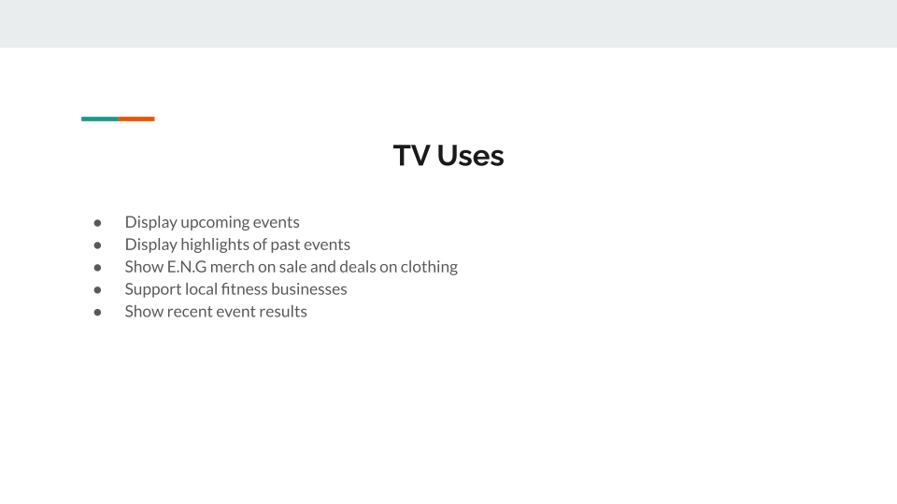

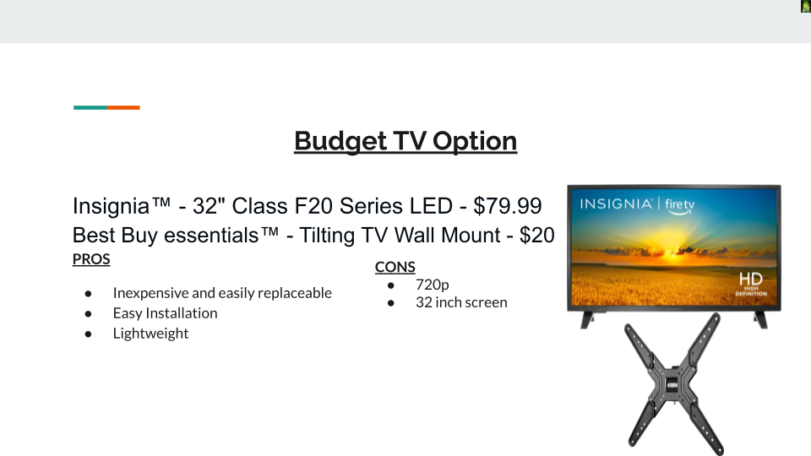

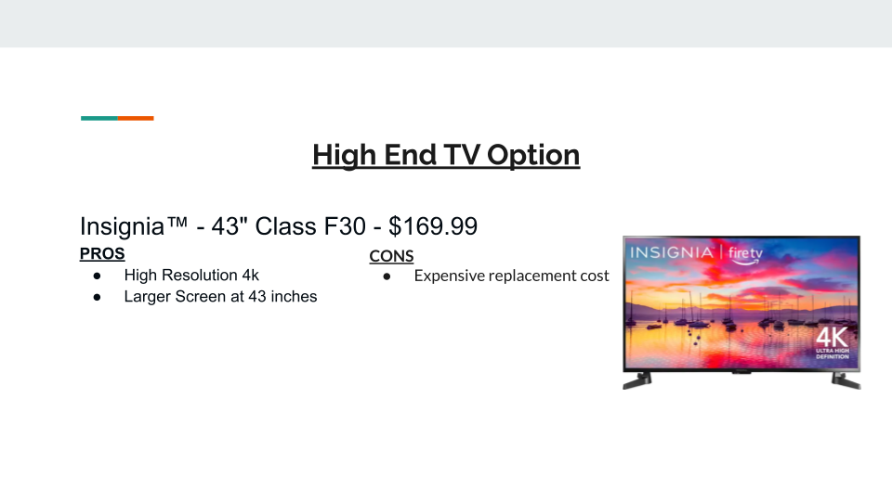



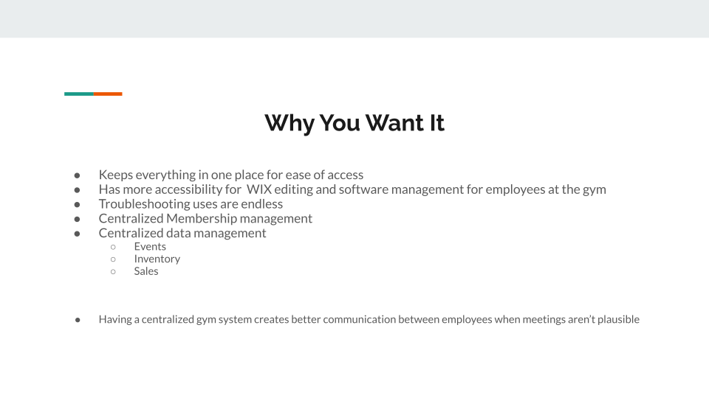

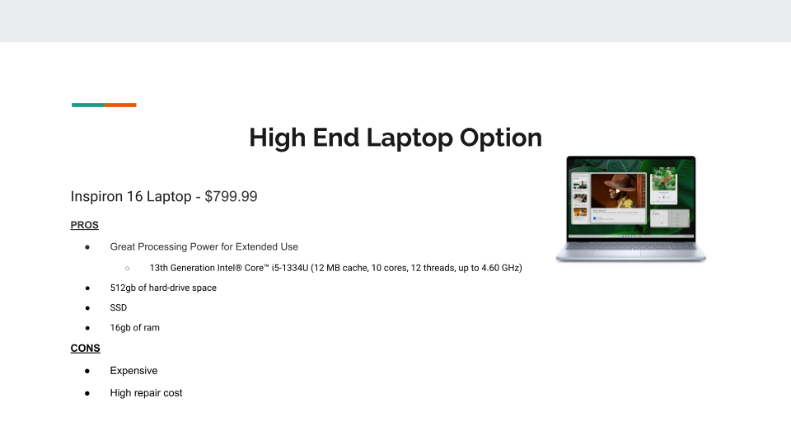

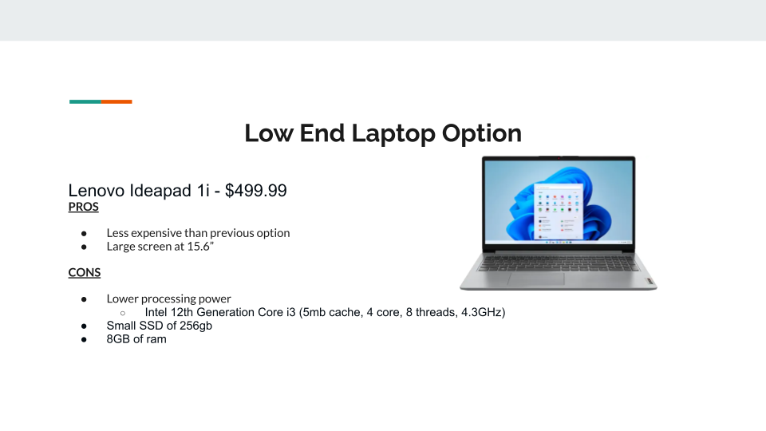

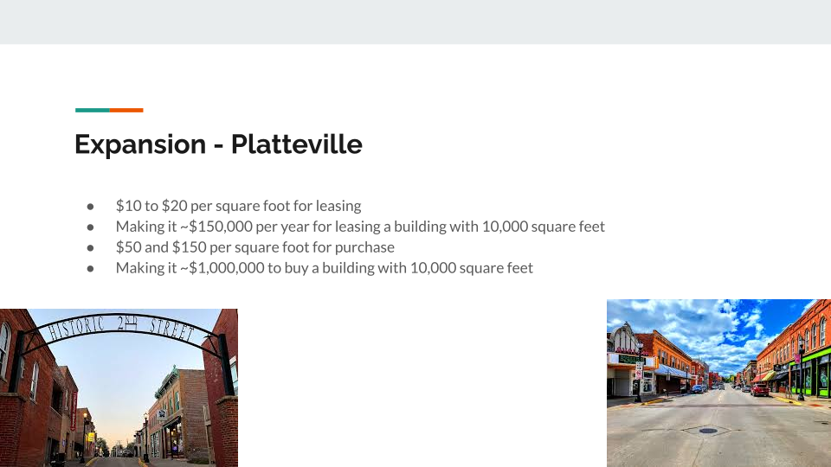

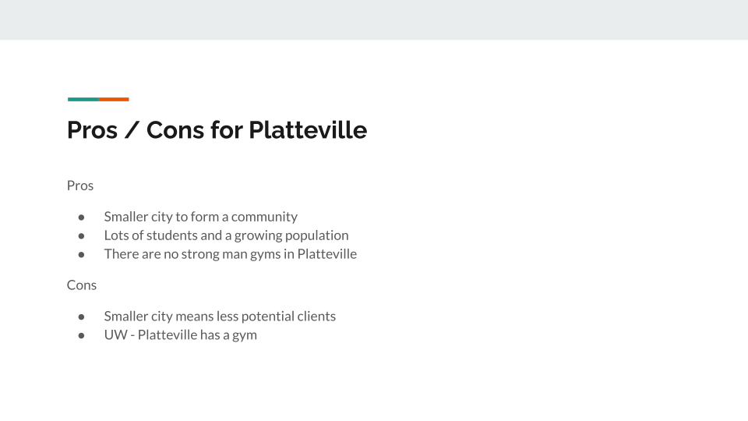

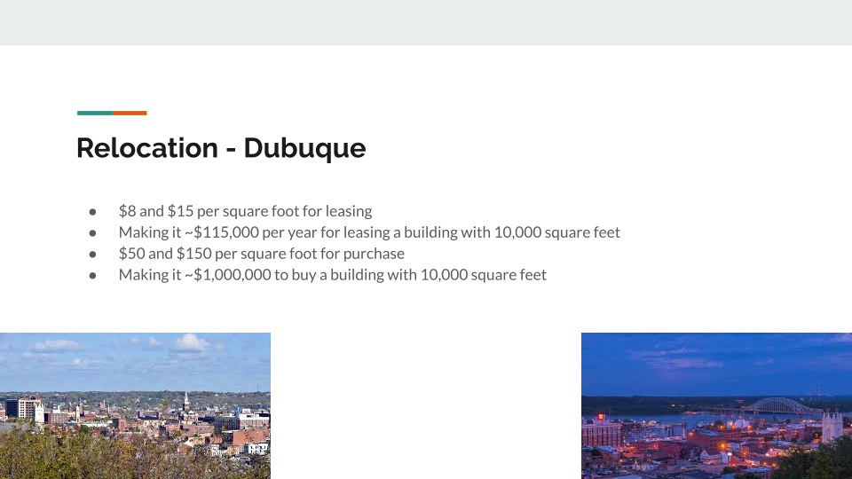

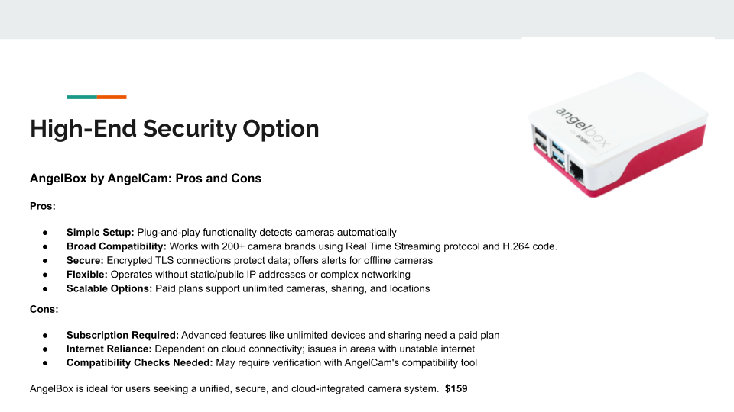

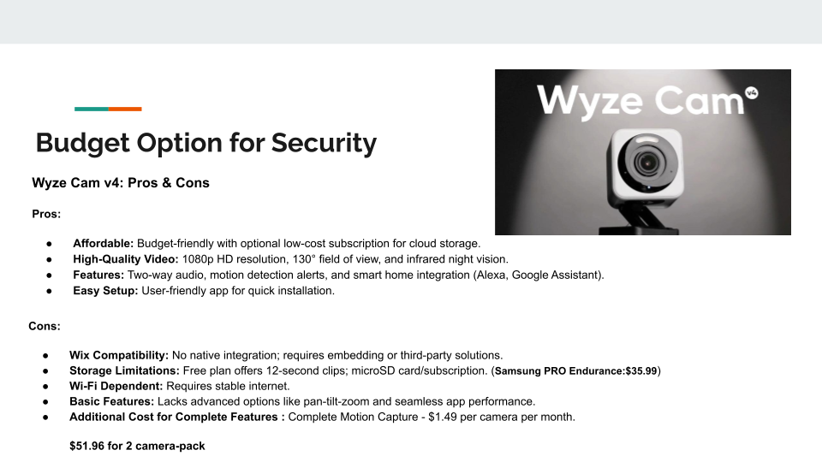

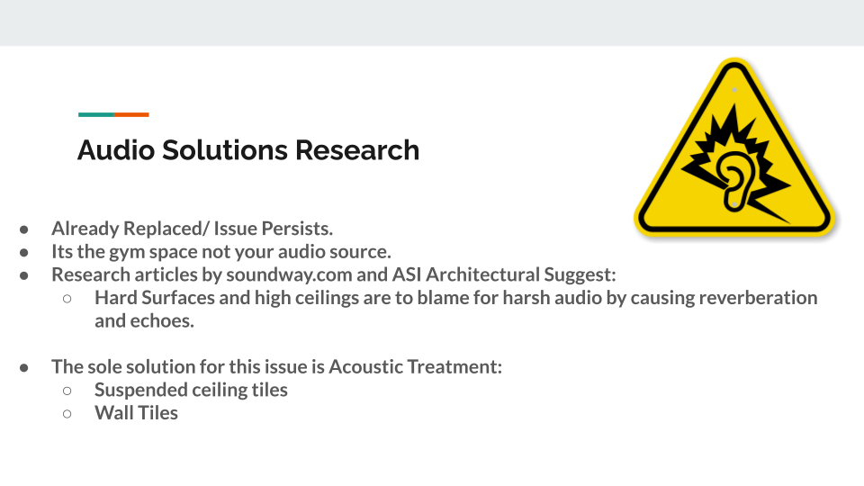

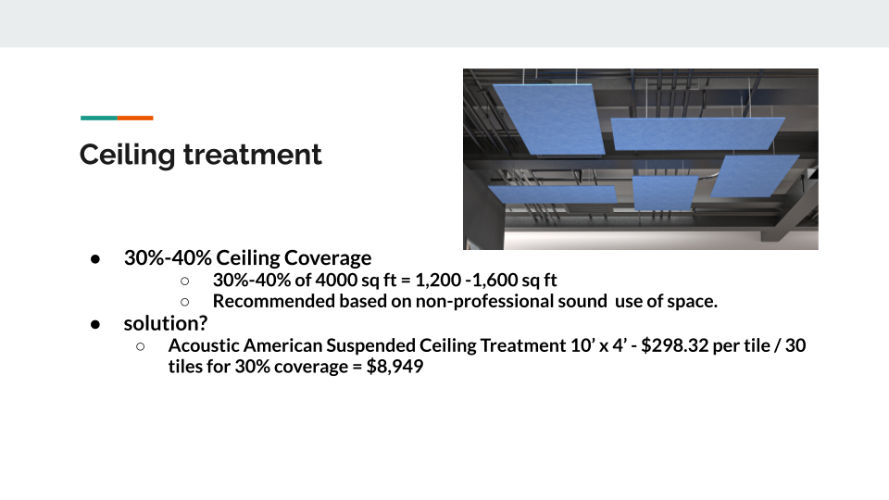

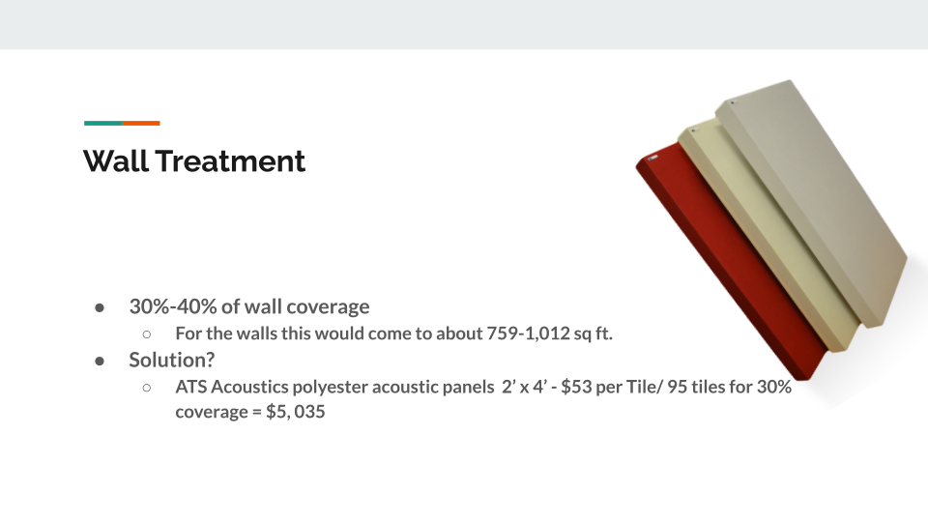



**Data Flow Diagram**

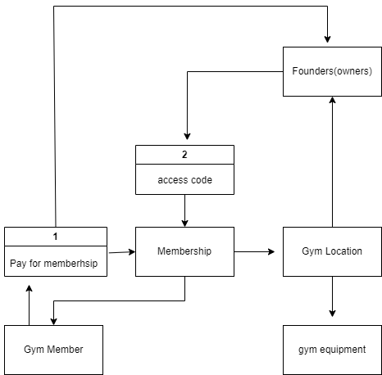

**TV Needs**

# Insignia™ - 32" Class F20 Series LED HD Smart Fire TV - $79.99

# Best Buy essentials™ - Tilting TV Wall Mount for Up to 50" TVs - $20

**Why you could need a TV**

Provide entertainment in the gym, display upcoming events, social media posts in real time, highlights from meets, advertisement for apparel or even displaying music being played.

**Laptop for central control**

Dell Precision 5530 15.6" LCD Mobile Workstation with Intel Core i7-8850H 2.6 GHz, 16GB RAM, 512GB SSD - $349.99

Dell Inspiron 16 Laptop AMD Ryzen™ 7 8840U 8-core/16-thread Processor with Radeon™ Graphics - $699.99

**Uses for the laptop**

Having a laptop in your business can be used for many things, like tickets for maintenance or better centralized control over camera systems and updating hardware and software within the gym with the keypad or sound system or the in house entertainment.

Peavy makes a DI box that takes USB from the computer and converts it to XLR out. - **Peavey USB-P USB Playback Device - $79.99 - This could be a replacement for the existing bluetooth player with the laptop combined.**

**Audio Solutions**

Rockville 2 WET-6525B 6.5" 70V Commercial Indoor/Outdoor Wall Speakers in Black - $139.95 for 2 speakers - 40 watts 4 way swivel wall mount.

Use existing PA system but move it to more sheet metal friendly areas and limit volume to eliminate ear blasting. Use laptop to mix or get a inbetween mixing modules to keep it from getting too loud.

# **Harbinger LV7 7-Channel Analog Mixer With Bluetooth - $64.99**

This would be the best budget option to control sound EQ and mixing without being complicated or sacrificing quality for budgeting. Could connect existing bluetooth connection dongle to it and hide the EQ in the closet. Many people play music extremely loud with poor EQ causing irritation in others, with this concern even if mentioned to the user they can only turn down their music to solve the issue when its really an EQ issue.